**Results:**

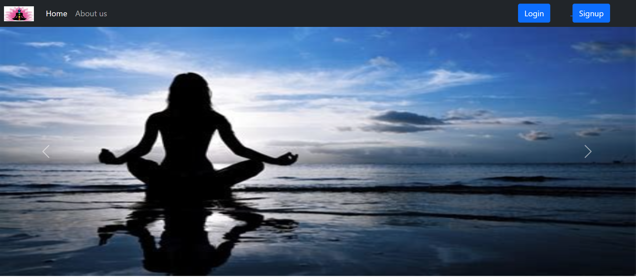

**Fig1.1 Home (carousel 1)**

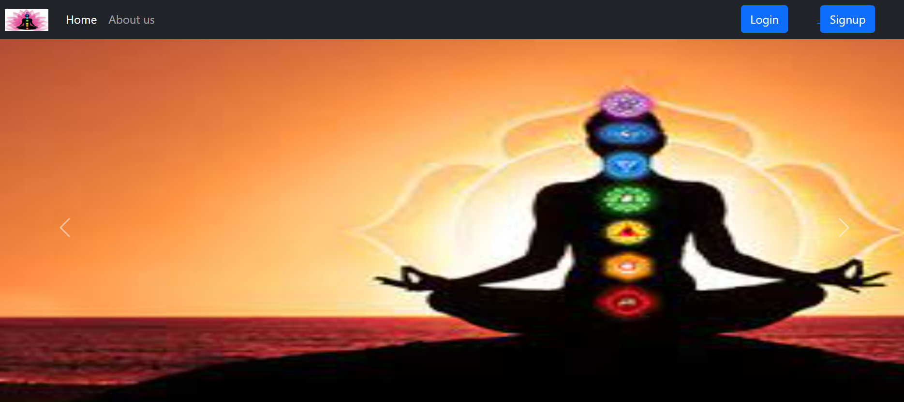

**Fig1.2 Home (carousel 2)**

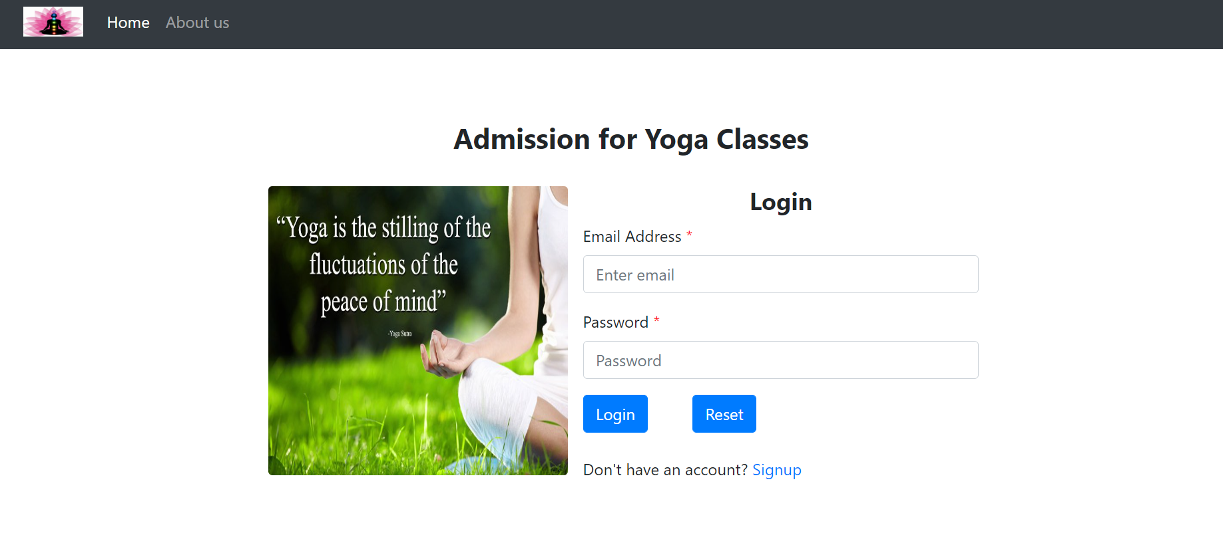

**Fig2. User admission login**

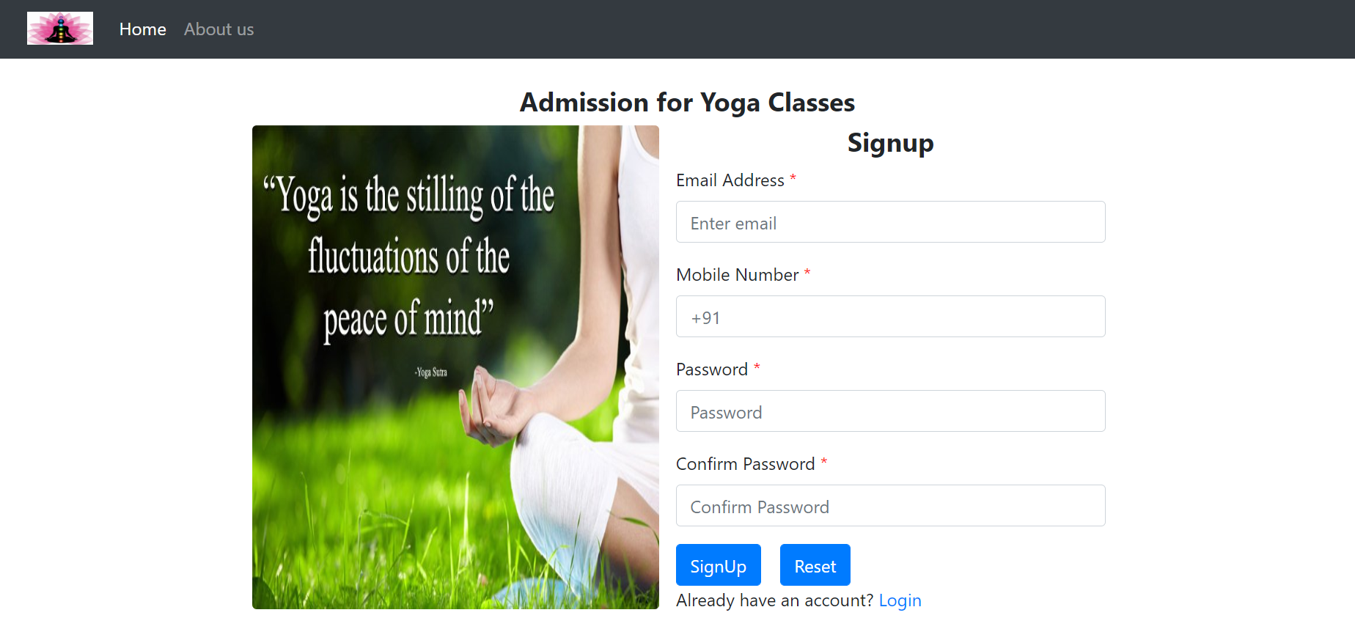

**Fig3. User admission registration**

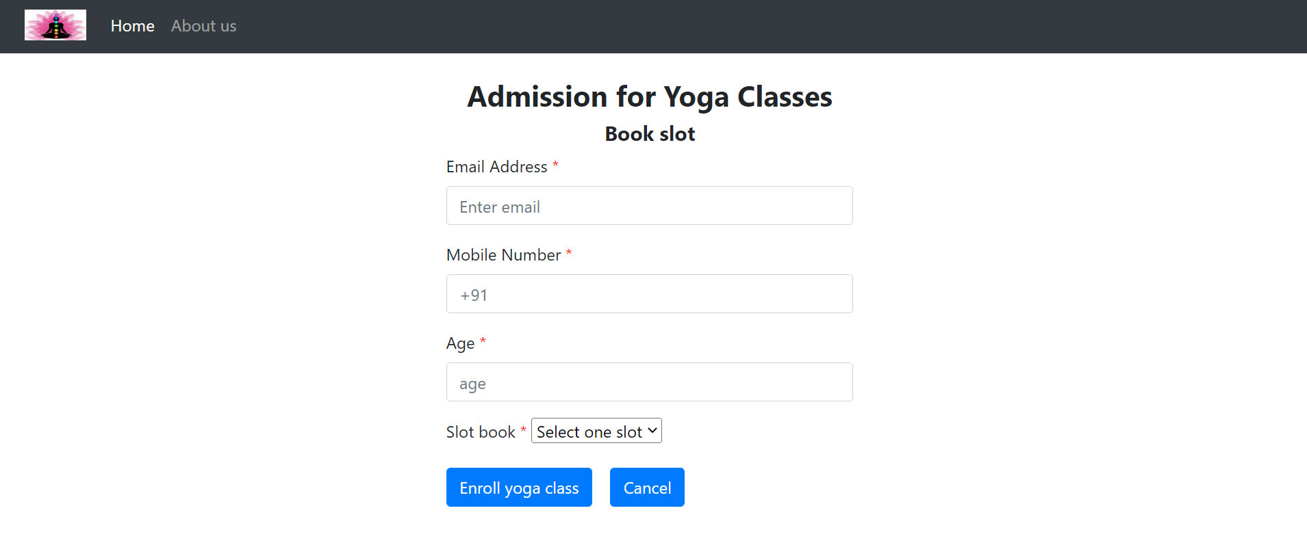

**Fig4. Booking a slot for admission**

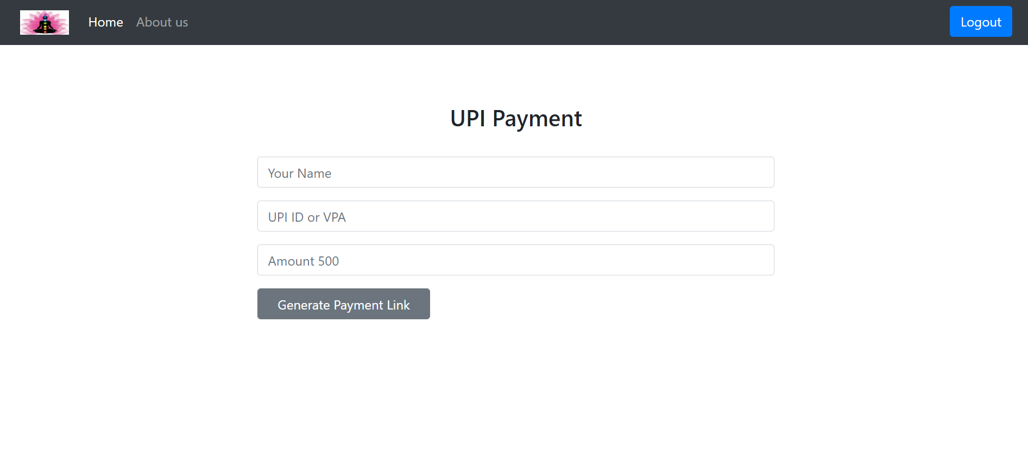

**Fig5. UPI payment**

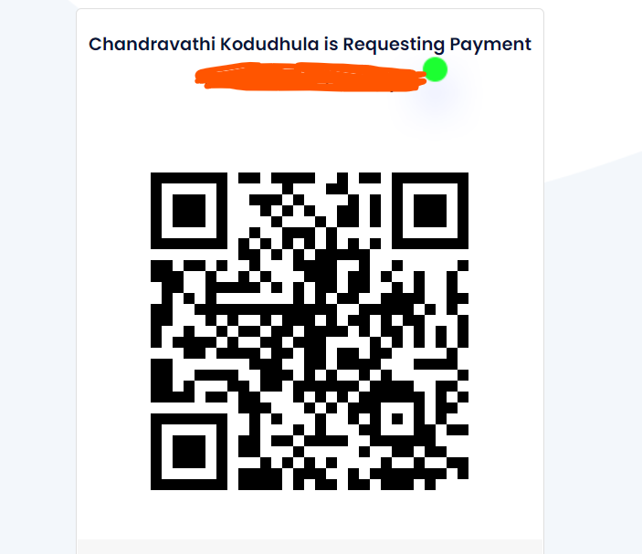

**Fig6. Scan and pay amount for admission**

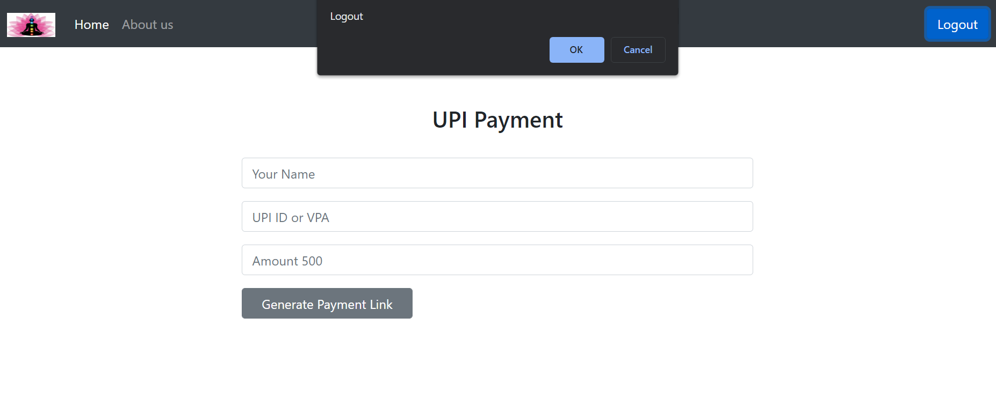

**Fig7. Page says a popup to logout 🡪 jump to login page (after logout)**

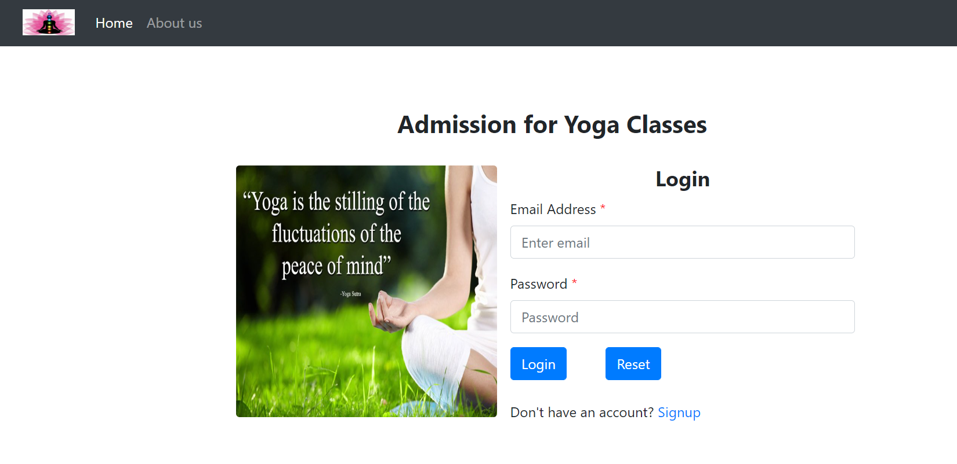

**Fig8. After logout 🡪 back to login page**

Payment process using card (extra module)

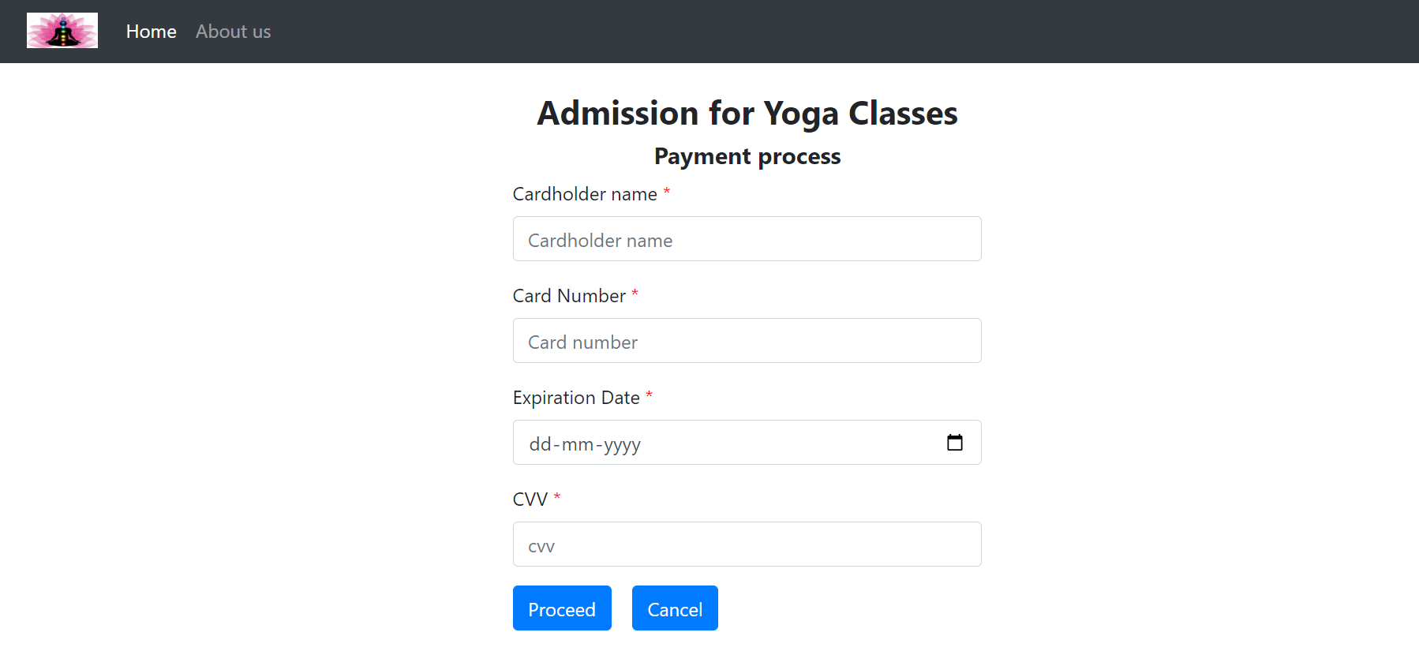

**Validation:**

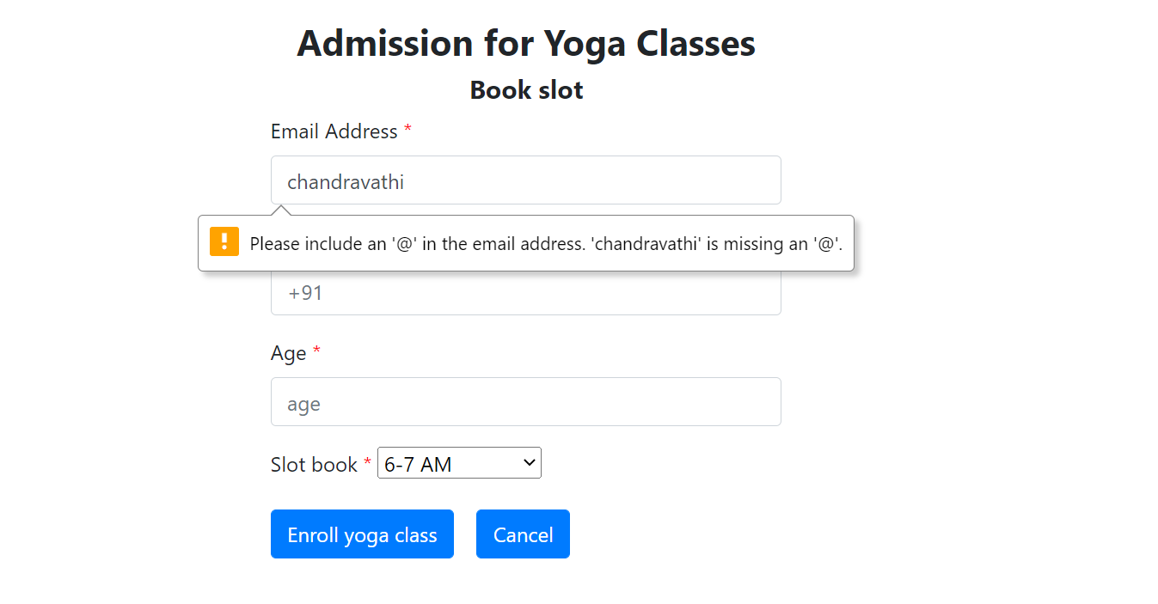

**Fig9.1 Slot booking page email validation**

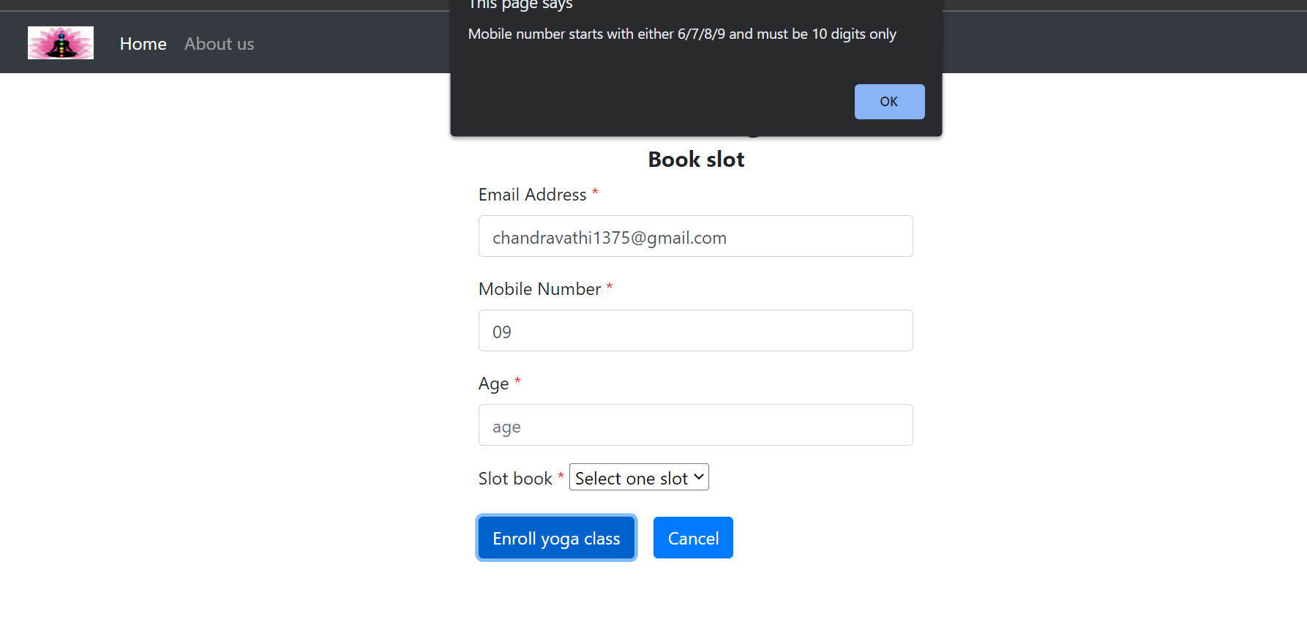

**Fig9.2 Slot booking page mobile number validation**

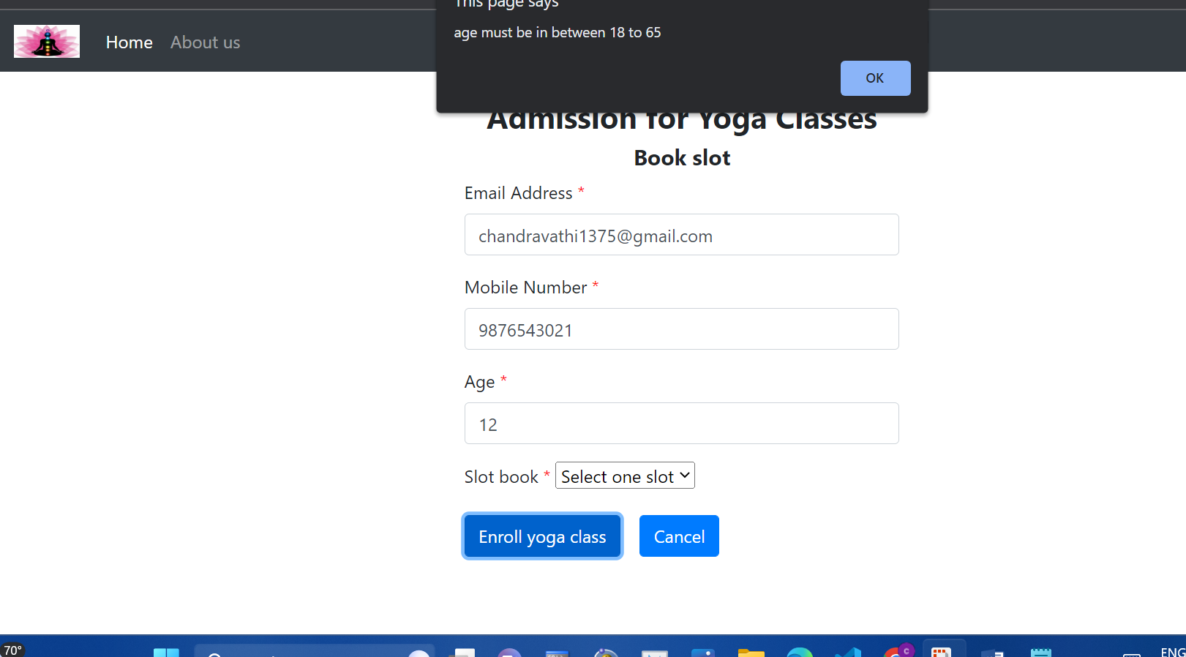

**Fig9.3 Slot booking page age validation**

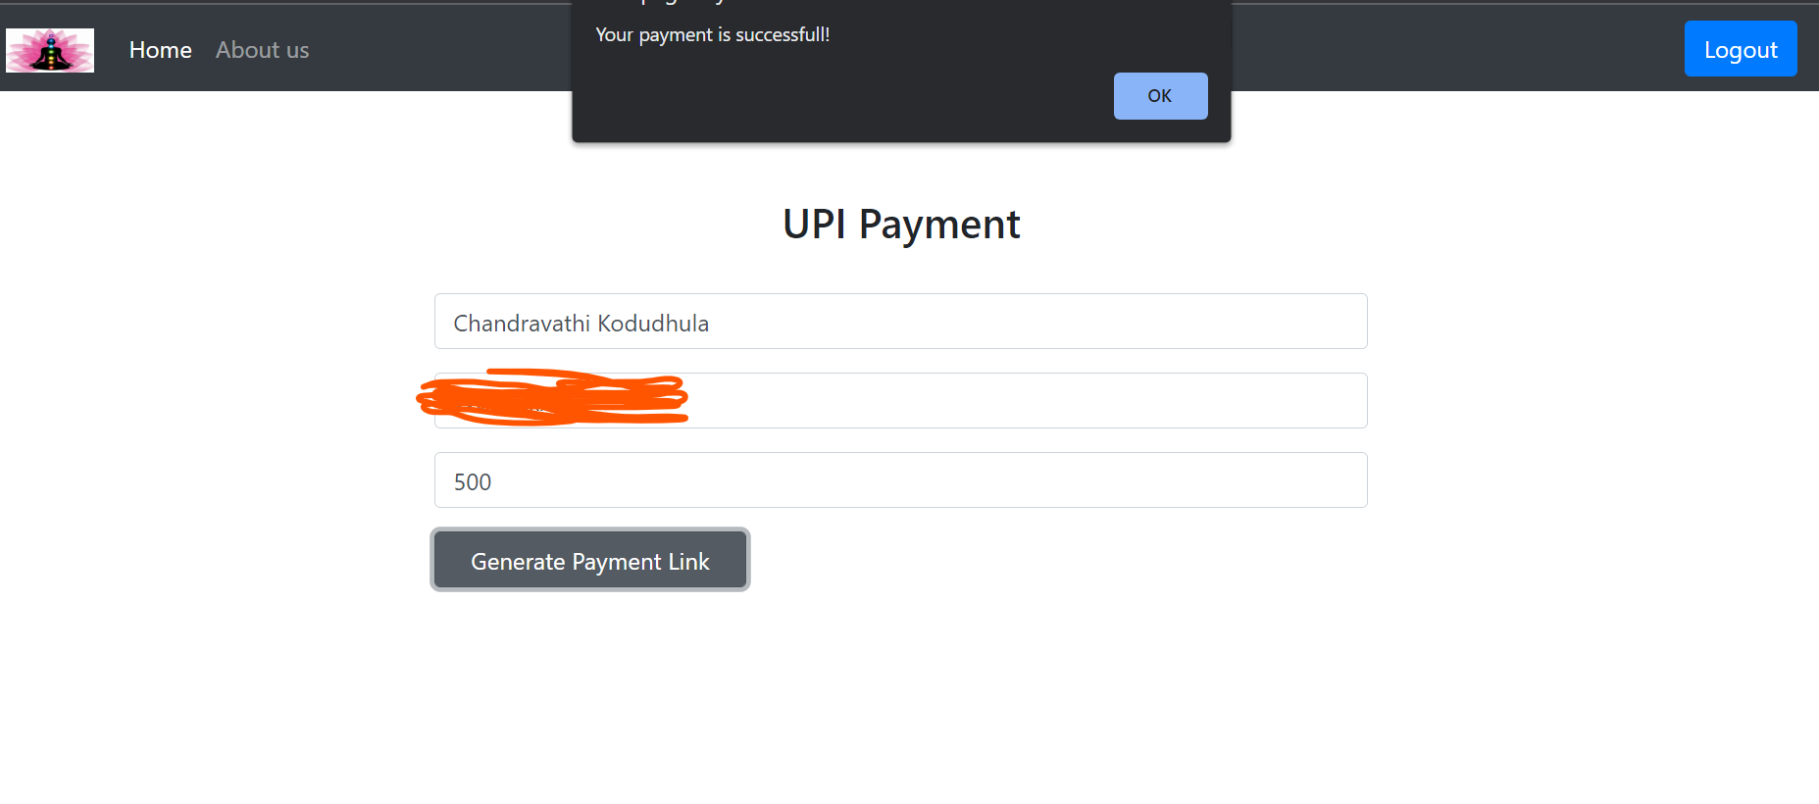

**Fig10. Payment successful!**

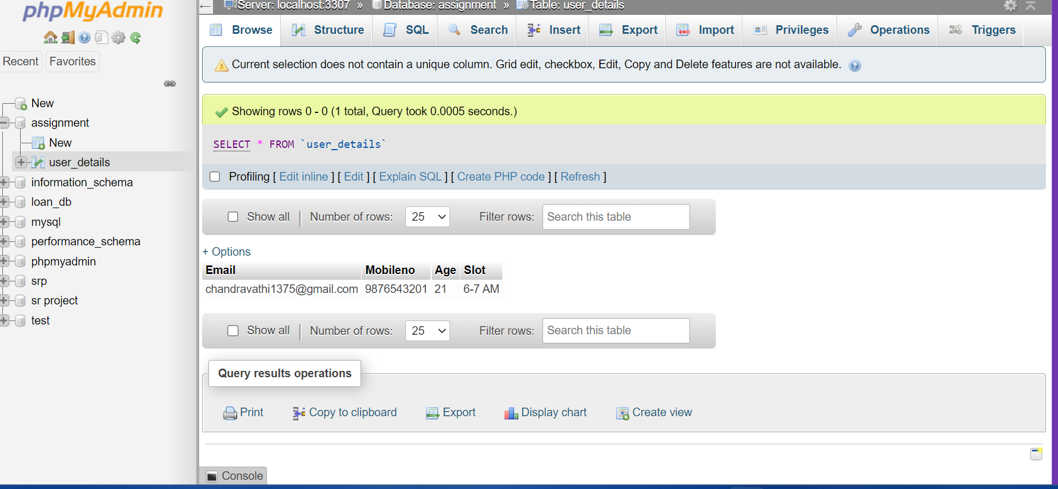

**Fig11. Admission user data stored into Xampp local server**

**ER Diagram**

Home

Login

User account

Don’t have an account

Signup

If user already account

Successful

Payment

7-8 AM

8-9 AM

5-6 PM

6-7 AM

Admission for Yoga Class

Slot timings

Conditions

Process for payment

No

Unsuccessful

Yes